ISLAMIC UNIVERSITY OF TECHNOLOGY
Organization of Islamic Cooperation
Board Bazar, Gazipur

Why the iOS App Store
Generates More Revenue
Than Google Play Store
CSE 4643

CSE'18
December 06, 2021

Introduction
Android and iOS are two of the largest mobile operating systems in the world. Together, they basically dominate the mobile market.
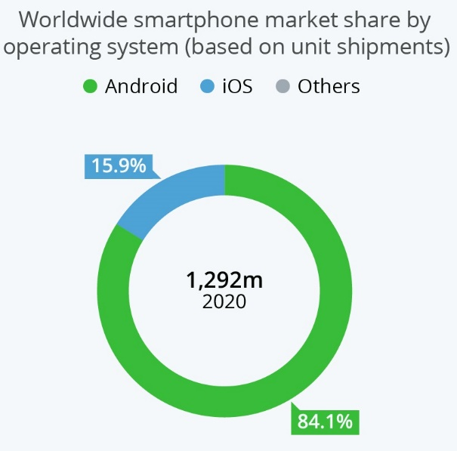
Source: IDC
If we look at the number of application downloads for Google Play Store and the iOS App Store, the official application distribution services for Android and iOS respectively, we see a similar story.
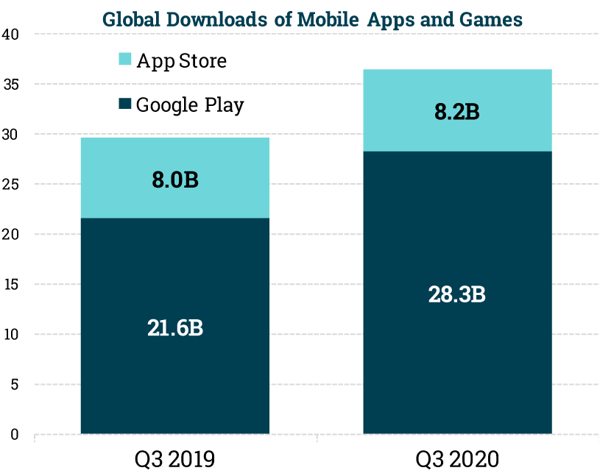
Source: Sensor Tower Store Intelligence
So far, things make sense. Since Android has a higher market share, the number of application downloads on Google Play Store is higher. However, if we look at revenue from the two distribution services, things start to get confusing.
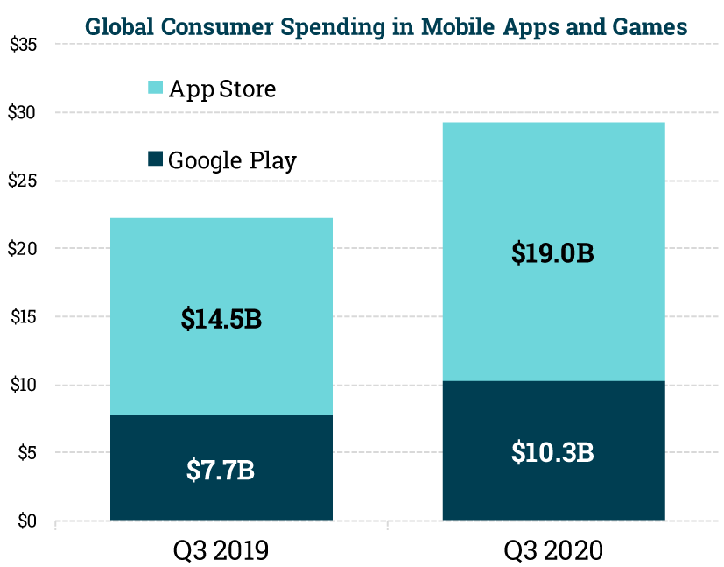
Source: Sensor Tower Store Intelligence
Even though the iOS App Store has far fewer downloads, it boasts a far larger revenue. In the following sections, we will be exploring two of the major reasons behind this, monopolization and user base differences. However, this is by no means an exhaustive list. The monopolization practices of Apple in particular, should be seen as just the starting point of a much larger discussion on the various unethical practices of the company in general.

Monopolization
Apple ties people into an eco-system. Every application that is installed onto an iOS device must be downloaded through the official play store. It is insanely difficult to sideload an application onto an iOS device.
The same is not true for Android devices. Google has made it extremely easy to sideload an application, with a simple warning to make sure that the user knows what they are doing (after all, it can be a bit risky).
This is important because it results directly in higher revenues. In order to give users the freedom to install anything they want onto the devices they bought, Google must put up with a large range of competitors, including alternative app stores, developers releasing APK files on their own websites (something which Epic Games famously did to bypass Google Play Store) and plain old piracy. By restricting how their users can interact with their devices, Apple avoids having to deal with this.

User Base
As uncomfortable as it may be, the truth is that the vast majority of iOS users come from affluent countries like USA and UK, while the vast majority of Android users come from countries that are less well off financially, such as India or Brazil. Of course, the reason this situation exists in the first place is because iOS devices are mostly marketed to richer audiences and are priced accordingly, regardless of their actual worth. Android devices on the other hand, are manufactured by a wide variety of companies, resulting in a range of prices and configurations.
This simple fact results in Apple having a user base that can afford to and is willing to spend more money on the iOS App Store.
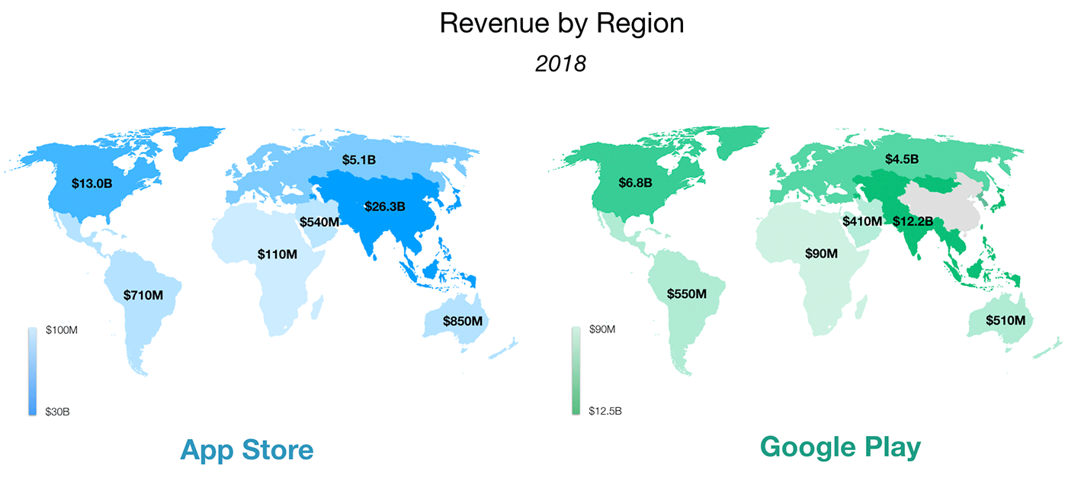
Source: Sensor Tower Store Intelligence
Also notice that Google Play Store has no revenue from China. It’s banned there, thus depriving Google from a potentially huge user base.

